COVID- 19 Virtual Tea: It's Not About Me!

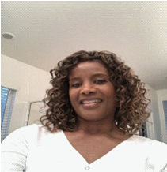
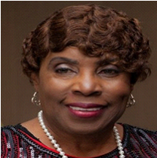

Kay W. Coulson n-ACTION CEO
Nancy Ford Event Emcee
Letitia Clark Homeless Advocate

Event Details
Connie Leathers Domestic Violence Advocate
Tonya Whiteside Grief & Loss

Saturday, October 17, 2020
1:00 PM - 3:00 PM PST
Registration: Begins September 15, 2020
RSVP - Before October 12, 2020 Cost: $60 per person
Games, Raffles, Special Awards!
Important: If you are interested in participating during the live Virtual Tea, you will need to let us know in your registration.
You may purchase tickets or donate to n-ACTION Family Network
www.n-actionfamilynetwork.org
P.O. Box 1715 La Mirada, CA 90637-1715 via Check, Zelle, or Cash App
If you are unable to attend, you may support us by donating. All donations are tax- deductible. Your donations will support COVID –19 homeless projects.

